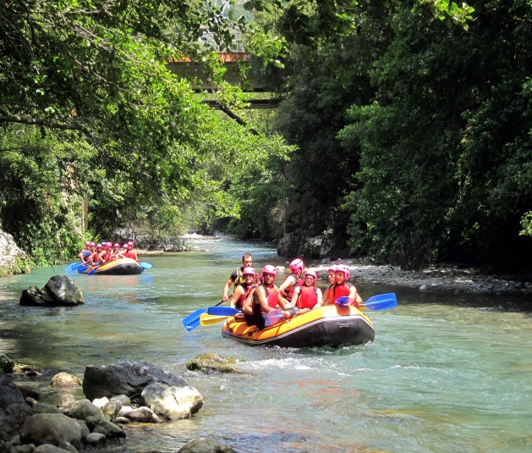

Wild, Wonderful, West Virginia

Rafting Trip on the New River Gorge

Friday, July 20th – Arrive
Saturday, July 21st – Raft
Sunday, July 22nd – Leave
Ace Adventures Resort
ACEraft.com

Cut and deliver to Parish Office, or email to kraft.joseph@yahoo.com
_ _ _ _ _ _ _ _ _ _ _ _ _ _ _ _ _ _ _ _ _ _ _ _ _ _ _ _ _ _

Name: _________________________________________ Deposit: $25/person
Email Address: __________________________________
Number of Rafters: ______________________________

Lodging (circle one): *Raft all Day – Includes Lunch $109/person
*Camp with my tent $9/night/person
*Add Camp with Ace Tent /Sleep Pad $10/night/person
*Cabin $150/night/person
*Other – on my own
**Food Package: YES NO

*All Costs Are Approximate

** Saturday Breakfast: $11.00 - Saturday Dinner: $22.00

